Your contribution to Sustainability
You do the CHANGE

6 June 2023/online
Join Zoom Meeting
https://us05web.zoom.us/j/88001806684?pwd=RmJFaVBBeElRSGplbFhjbXg5ME5lQT09

Meeting ID: 880 0180 6684
Passcode: i0kuRn

17:30

17:40

18:05

18:30

Welcome and Introductions

The shift from traditional to circular economy
Brikene Dionizi, lecturer at the University of Shkoder “Luigj Gurakuqi”
- Brief introduction on the concepts
- How can the economy shift from traditional to circular
- Possibilites and challenges
- Discussions

Sustainability, what can I do?
Loreta Cermeli, student at the University of Shkoder “Luigj Gurakuqi”
- Practical strategies anyone can use to contribute to sustainability
- How can people be encouraged for their contribution
- Possibilities and challenges
- Discussions

How can we contribute to clean waters?
Dritan Rustja, lecturer at the University of Shkoder “Luigj Gurakuqi”
- Clean waters and sustainability
- Sustainable develepment of water resources
- Challenges of Albania for clean waters
- Discussions

 | 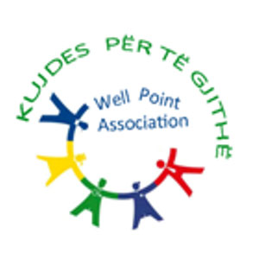

18:55

19:20

Ecotourism activities in the Lake of Shkoder
Aurora Piroviq, executive director at Well Point Organization
- Lake of Shkoder, its importance for the local community
- Lake of Shkoder as part of the ecosystem
- Ecoactivities in the Lake of Shkoder
- Discussions

Final conclusions and recommendations

*Language of the meeting Albanian/ meeting will be recorded

Language of the meeting Albanian/meeting will be recordedLang.

